Department of Computer Engineering
Academic Term: Jan-May 23-24

Class: B.E Computer Sem -VII Subject: Blockchain Technology Lab Subject Code : CSDL7022
Practical No: | 2
Title: | Creating the Smart Contract
Date of Performance:
Date of Submission:
Roll No: | 9427
Name of the Student: | Atharva Prashant Pawar

Evaluation:
Sr. No | Rubric | Grade
1 | Time Line (2)
2 | Output (3)
3 | Code optimization (2)
4 | Post lab (3)

Signature of the Teacher :
Experiment No. 2
Creating the Smart Contract
Atharva Prashant Pawar - (9427) [Batch - D]
Aim: Creating and deploying Smart Contract using Solidity and Remix IDE.
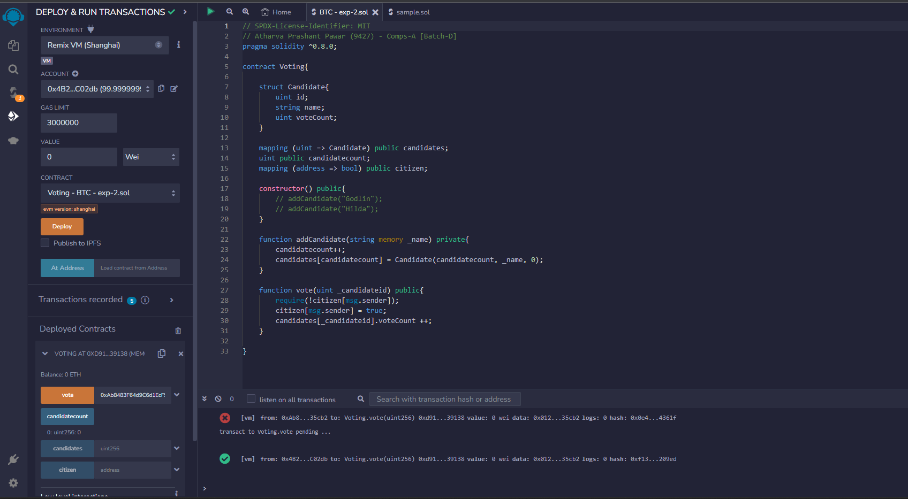

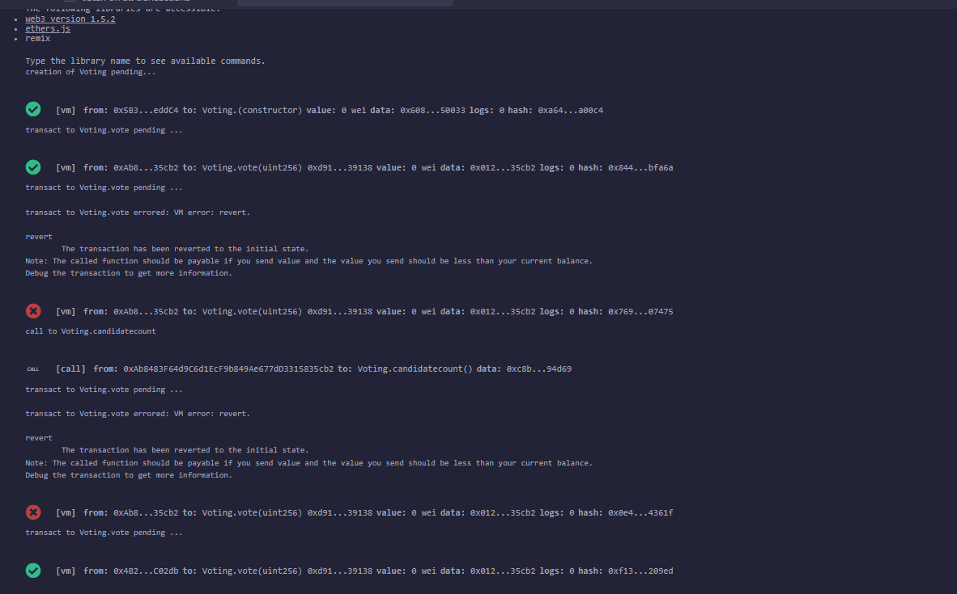

Conclusion: We have successfully created and deployed the smart contract.

Review Questions

Q. 1 What is Remix IDE?
Q. 2 How smart contract is created using Remix IDE?
Q. 3 How the smart contract is deployed using Remix IDE?
Q. 4 What is Gas?
Q. 5 What is account in Remix IDE?
